**ACCLAIM DOCUMENTATION**

**1.Process Data**

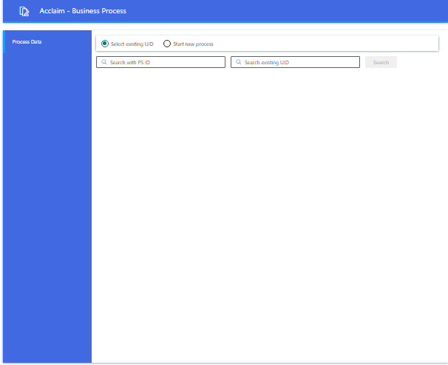

1.a. To start new process click on the “start new process” radio button.

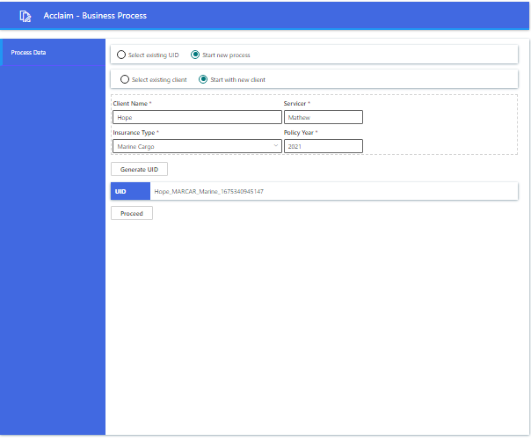

1.b. To create new client click on the “start with new client” radio button and fill the required details and click on “Generate UID” button , then the new UID will be generated.

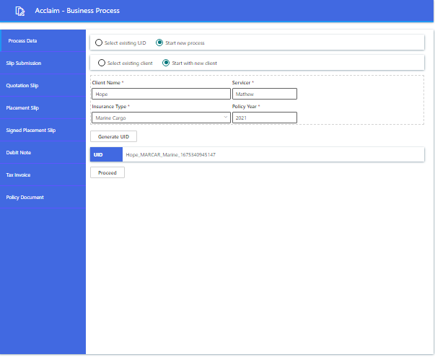

1.c. Click on the “Proceed” button ,all the tabs will be loaded.Now we can select each tab and continue with the process.



1.d. On clicking “select existing UID” , we could either search with PS ID or with existing UID.

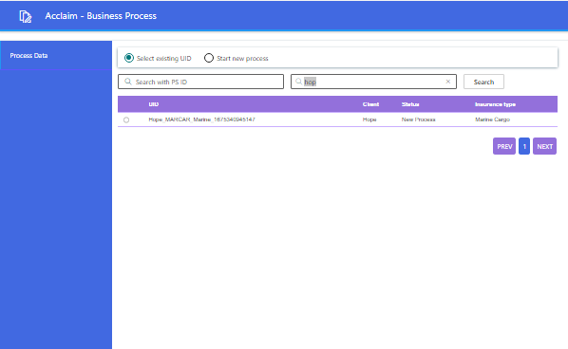

1.e. Search an existing UID with minimum three characters and click on the “Search” button. All the UID’s starting with the searched characters will be displayed.

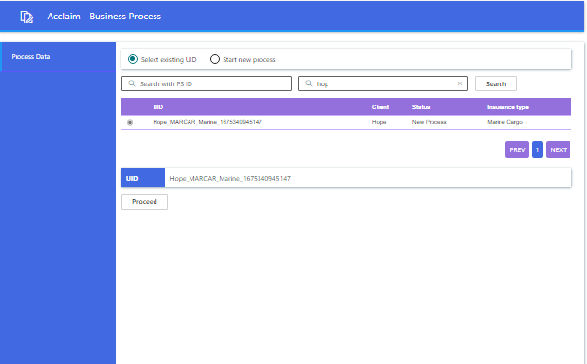

1.f. Click on the radio button and click on the “Proceed” button.

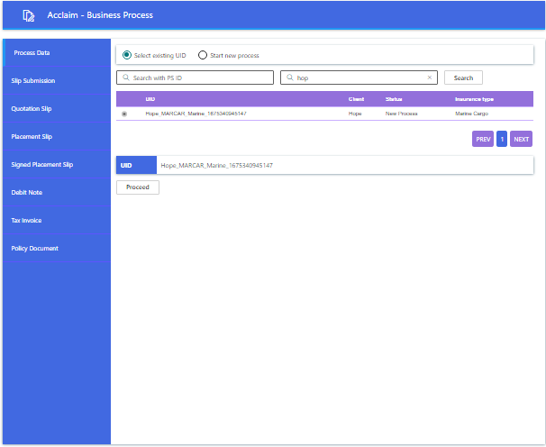

1.g. All the tabs will be loaded. Now we can select each tab and continue with the process.

**2.Slip Submission**

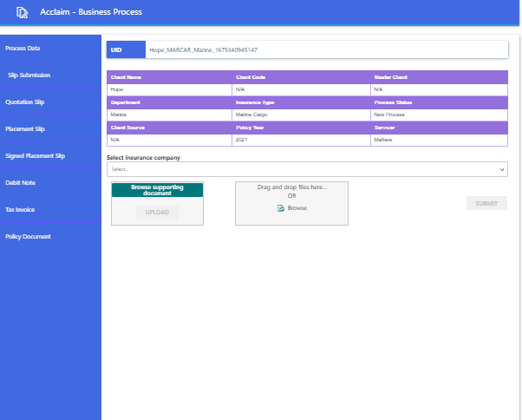

2.a. The common meta data of the selected UID will be displayed on the top grid. We could upload supporting documents if any by clicking on “Browse supporting document” and select the required file ,then upload using the “upload” button.

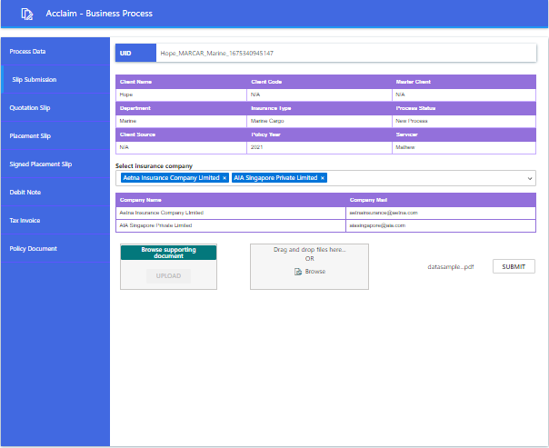

2.b. Select the insurance company/companies and attach files either by browsing or using drag and drop and then Submit.

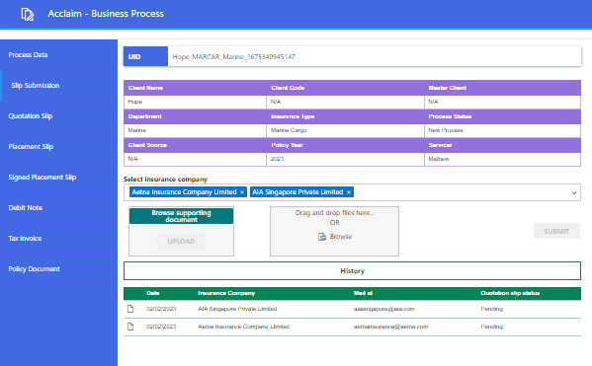

2.c. Slip submission history will be shown . “Quotation Slip status” will be updated to “Received” once Quotation slip is submitted.

**3.Quotation slip**

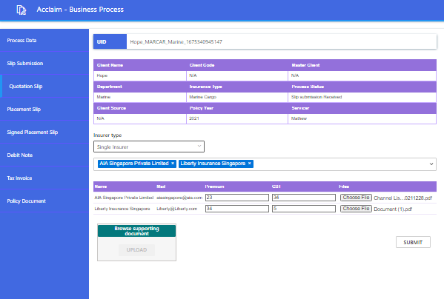

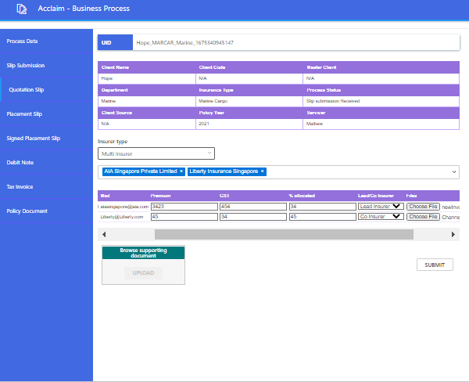

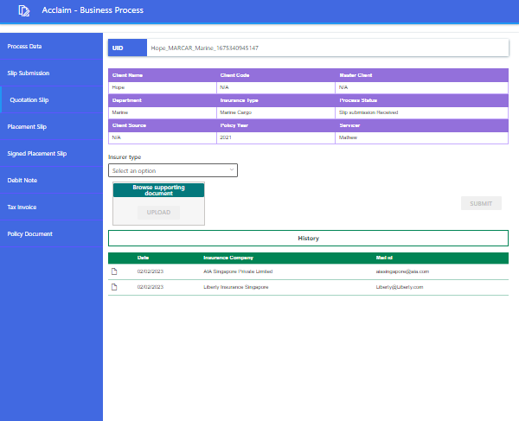

3.a. Select insurer type and enter all the required fields and click submit. Quotation slip history will be displayed.

**4.Placement Slip**

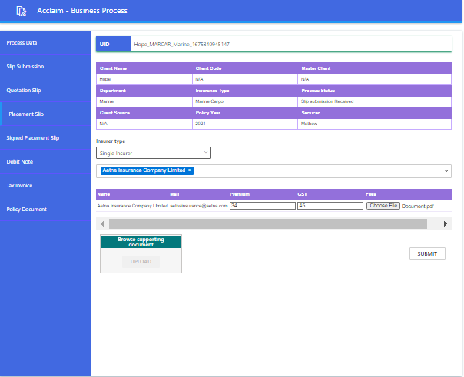

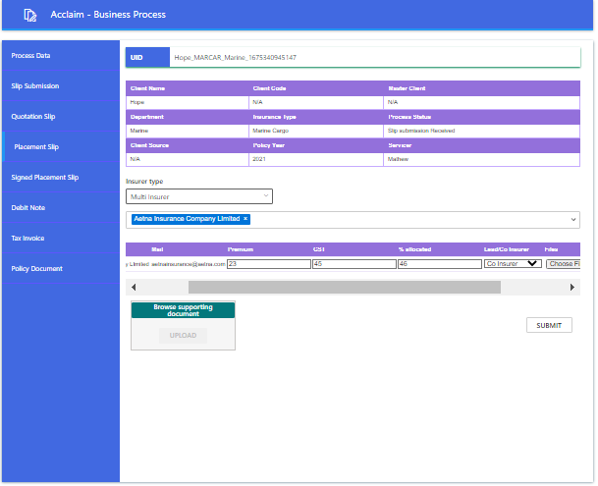

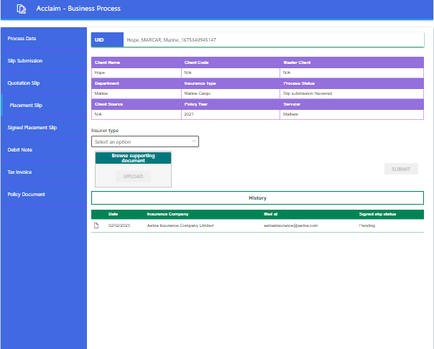

4.a. Select insurer type and enter all the required fields and click submit. Placement slip history will be displayed.

**5.Signed Placement Slip**

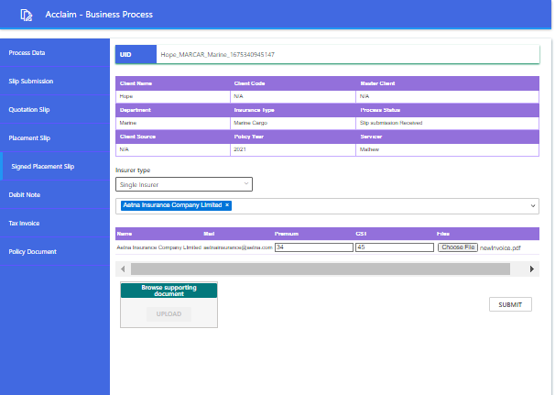

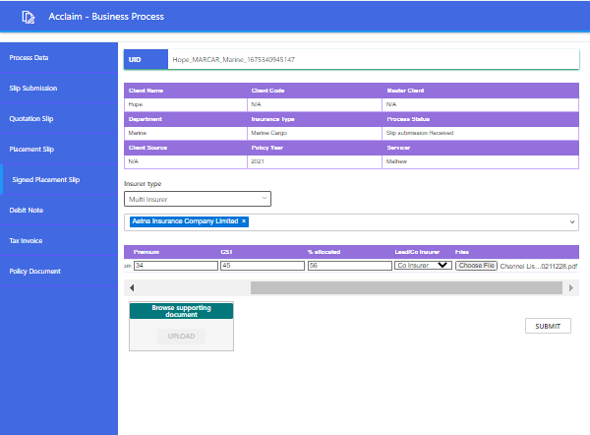

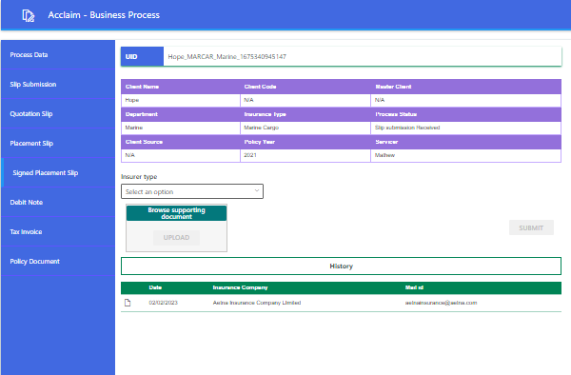

5.a. Select insurer type and enter all the required fields and click submit. Signed Placement slip history will be displayed.

**Mail Communication**

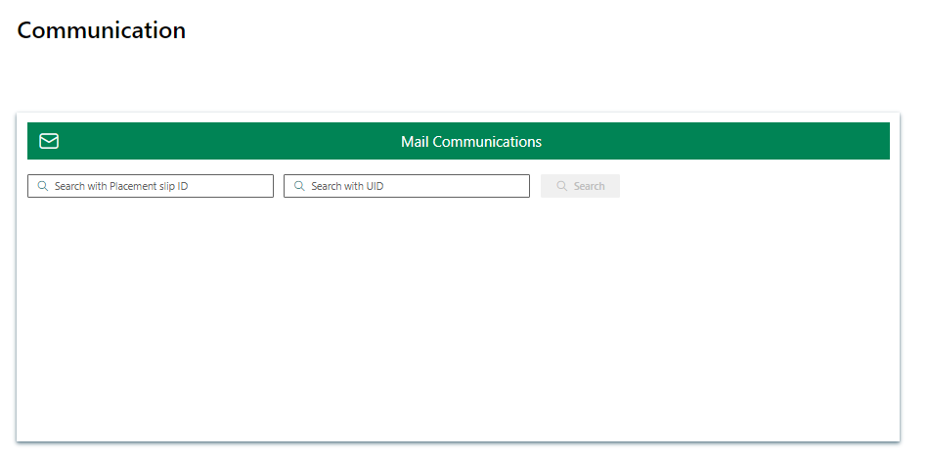

Search existing UID

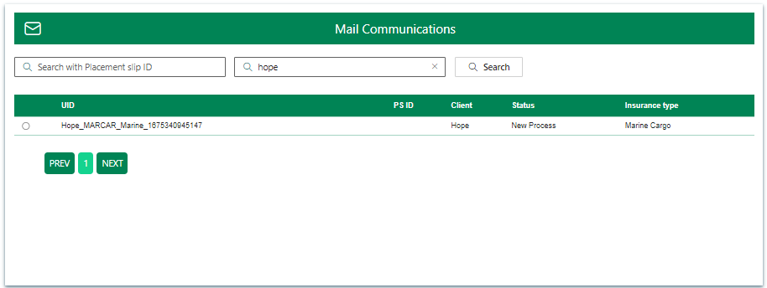

Select UID

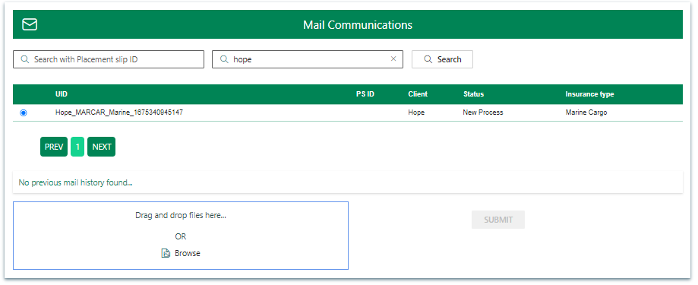

Drag & Drop or Browse a .msg file

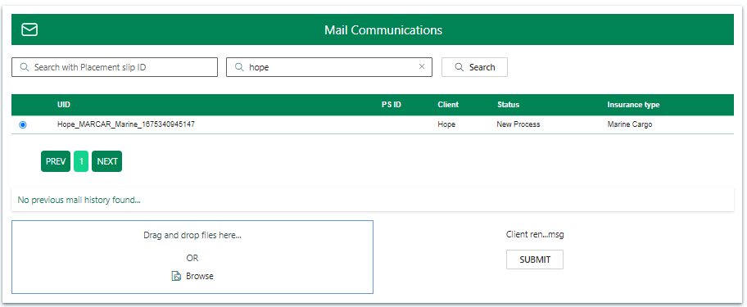

On submit click Mail item uploaded

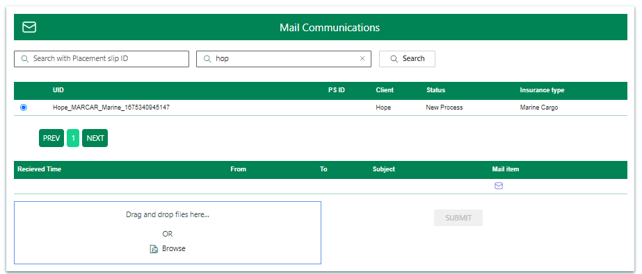

Central Document Management

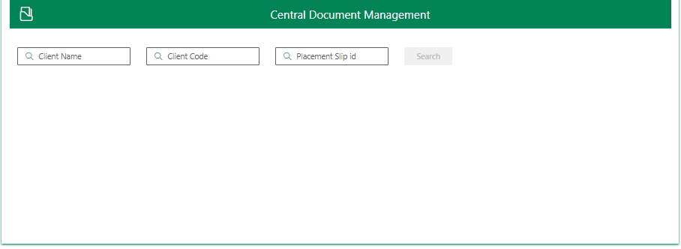

Search Client

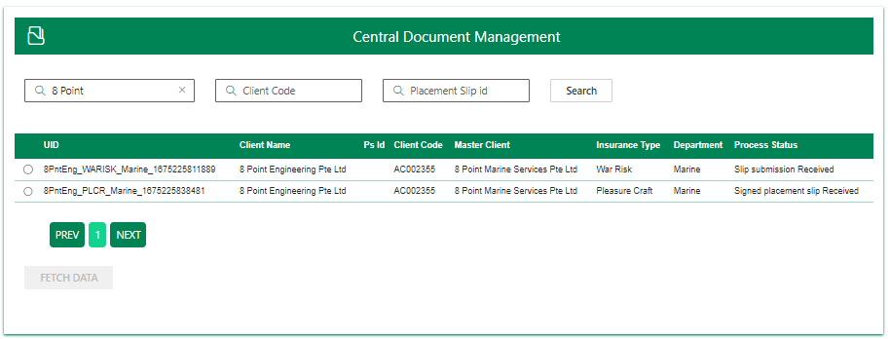

Select Client

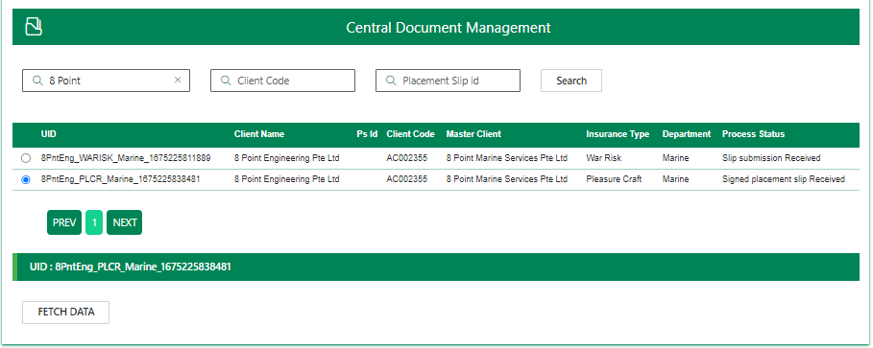

Fetch data of Client

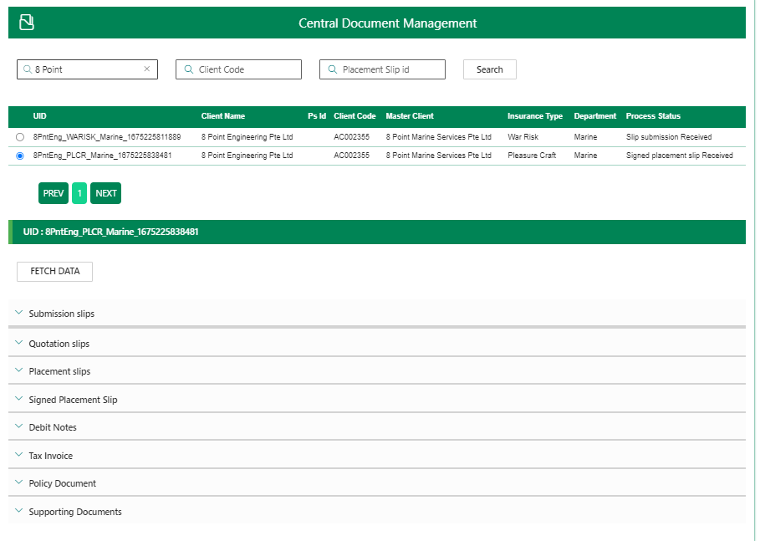

Submission History

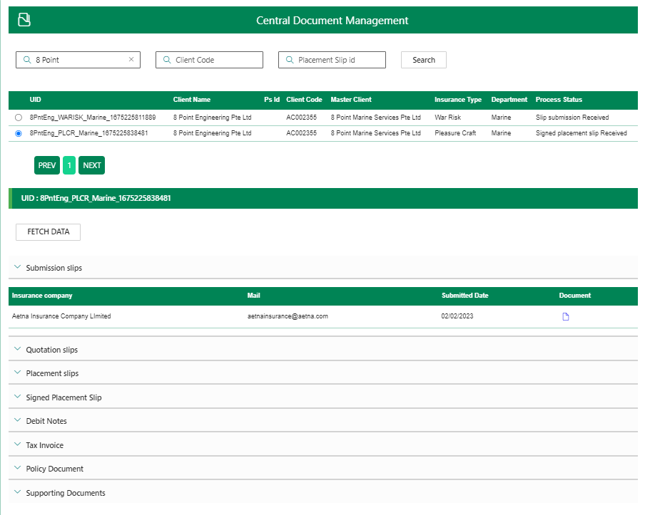

Quotation Slip History

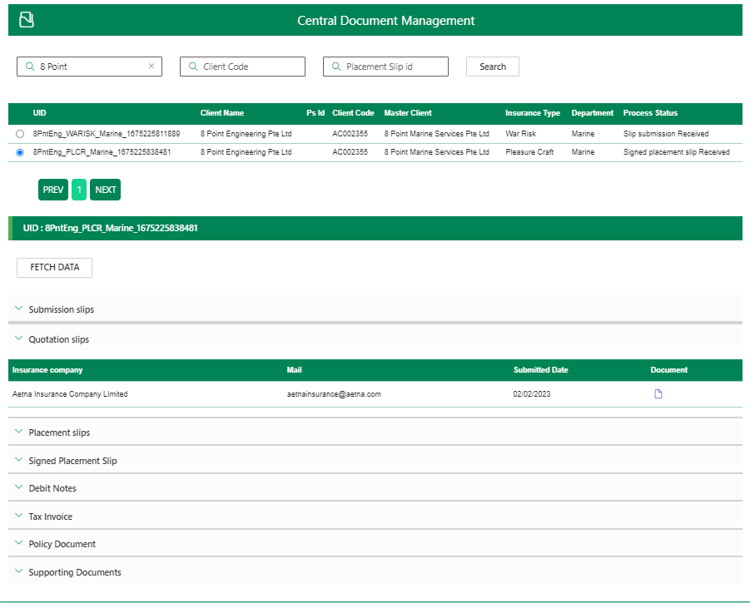

Placement Slip History

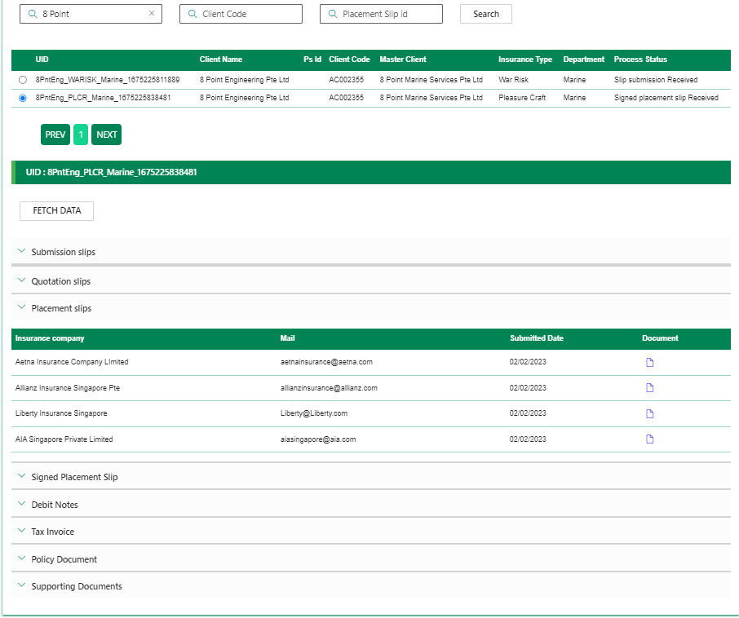

Signed Placement Slip History

